**SLIDE-1**

**Agenda**

* Clustering
* Hierarchical clustering
* Distance measures
* K-means clustering
* Anova & Tableau

**SLIDE-2**

**Primary Objective behind Clustering**

• Cluster Analysis (“data segmentation”) is an exploratory method for identifying homogenous groups (“clusters”) of records

• Similar records should belong to the same cluster

• Dissimilar records should belong to different clusters

**SLIDE-3**

Example: Fitting the Troops (from Data Mining Techniques by Berry & Linoff)

• The US army recently commissioned a study on how to redesign the uniforms of female soldiers. The army’s goal is to reduce the number of different uniform sizes that have to be kept in inventory while still providing each soldier with well-fitting khakis.

• Researchers Ashdown and Paal @ Cornell University designed a new set of sizes based on the actual shapes of women in the army. Unlike traditional clothing size systems, the new sizes are not an ordered set of graduated sizes where all dimensions increase together.

• Instead, they came up with sizes that fit particular body types (e.g., short-legged, small waisted, large-busted women with long torsos, average arms, broad shoulders, and skinny necks).

**SLIDE-4**

**Investment:**

Cluster securities based on financial performance info (return, volatility, beta) and other info (industry and market capitalization) to create a balanced portfolio

**Industry Analysis:**

For a given industry, cluster firms based on growth rate, profitability, market size, product range, presence in various international markets, to understand industry structure (determine competitors)

**SLIDE-5**

• Simple Clustering: 1-2 variables

• Visual inspection of data

**SLIDE-6**

**Clustering > 2 Variables**

• **Two approaches**:

– Compute “multivariate distance” between records, and group “close” records.

– Group records to increase within-group homogeneity.

**SLIDE-7**

**Two Types of Clustering Algorithms**

**Hierarchical methods** - **agglomerative**:

Begin with n clusters; sequentially merge similar clusters until cluster is left.

• Useful when goal is to arrange the clusters into a natural hierarchy.

• Requires specifying distance measure.

**Non-Hierarchical methods:**

Pre-specified number of clusters, assign records to each of the clusters.

• Requires specifying # clusters

• Computationally cheap

**SLIDE-8**

**Hierarchical Clustering**

**Dendrogram:**

Tree-like diagram that summarize the clustering process

• Similar records joined by links.

• Record location determined by similarity to other records.

**SLIDE-9**

**Hierarchical Clustering Algorithm**

• Start with n clusters (1 record in each cluster)

• Step 1: two closest records are merged into one cluster

• At every step, pair of records/clusters with smallest distance are merged.

– Two records are merged,

– Or single record added to an existing cluster,

– Or two existing clusters are combined.

• Requires a definition of distance

**SLIDE-10**

**Pairwise distance between**

**Records**

Distance Requirements: Non-negative (dij > 0)

dii = 0

Symmetry (dij = dji)

Triangle inequality (dij + djk  dik)

**SLIDE-11**

**UG Business Programs**

**Universities Clustering.xls**

• Data for 25 undergraduate programs at business schools in US universities in 1995.

• This dataset excludes image variables (student satisfaction, employer satisfaction and deans’ opinions)

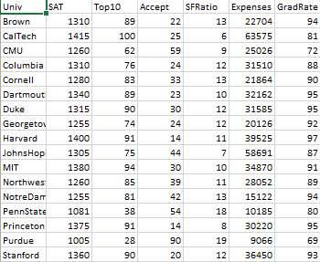

**SLIDE-12**

Distance between two universities

Notation:

xi = (xi1,xi2,…..,xip)

xJ = (xJ1,xJ2,…..,xJp)

Example:

• Caltech= (1415, 100, 25, 6, 63575, 81)

• Cornell = (1280, 83, 33, 13, 21864, 90)

**SLIDE-13**

**Euclidean Distance**

diJ **=** sqrt((xi1-xJ1)2 +(xi2-xJ2)2….(xip-xJp)2)

• 6-dimensional Euclidean distance between Caltech and Cornell:

Sqrt [(1415-1280)2 + (100-83)2 + (25-33)2 + (6-13)2 +

(63575-21864)2 + (81-90)2] = 41,711.22

**SLIDE-14**

**Standardize when there are multiple variables:**

The units of the different measurements influence Euclidean distance.

Solution: standardize (=normalize) each variable before measuring distances.

**SLIDE-15**

**Standardizing Example:**

*Z_SAT = (SAT-Mean (SAT))/Stdev (SAT)*

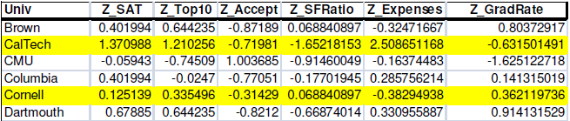

**SLIDE-16**

Euclidean distance between Standardized Caltech and Cornell:

Sqrt [(1.371-1.125)2 + (1.210-0.335)2 + … + (-0.632-0.362)2]

= 3.84

**SLIDE-17**

**Lots of other distance metrics**

Statistical (Mahalanobis) distance:

🡪Uses correlation matrix

Manhattan distance

DiJ = | xi1-xJ1|+| xi2-xJ2|+…..+| xip-xJp|

Matching-type metrics for categorical data (next slide)

**SLIDE-18**

Distances for Binary Data

Similarity-based metrics based on 2x2 table of counts

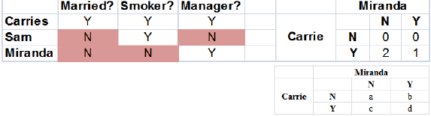

• Binary Euclidean Distance: (b+c)/ (a+b+c+d)

• Simple matching Coefficient: (a+d)/ (a+b+c+d)

• Jaquard’s coefficient: d/ (b+c+d)

• For >2 categories, distance =0 only if both items have same category. Otherwise =1.

**SLIDE-19**

Distances for Mixed (numerical + Categorical) Data:

• Simple: standardize numerical variables to [0,1], then use Euclidian distance for all.

• Gower's General Dissimilarity

Coefficient (next page)

• Gower's General Dissimilarity Coefficient

**SLIDE-20**

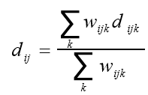

DiJ =

(wiJ1*diJ1+ wiJ2*diJ2+ wiJ3*diJ3+…..+ wiJk*diJk)/ (wiJ1+ wiJ2+ wiJ3+…..+ wiJk)

- diJk = distance provided by kth variable.

- wiJk = usually 1 or 0 depending whether or not the comparison is valid for the kth variable.

**SLIDE-21**

Distances Between Clusters: ‘single linkage’ (‘nearest neighbor’)

* Distance between 2 clusters = minimum distance between members of the two clusters

**SLIDE-22**

Distances Between Clusters: ‘complete linkage’ (‘farthest neighbor’)

* Distance between 2 clusters = greatest distance between members of the two clusters.

SLIDE-23

Distances Between Clusters: ‘average linkage’

• Distance between 2 clusters = average of all distances between members of the two clusters.

**SLIDE-24**

Distances Between Clusters: ‘centroid linkage’

• Distance between 2 clusters = distance between their centroids (Centers).

**SLIDE-25**

Pairwise distance between clusters

* + Single linkage (nearest neighbor): minimum distance between members of the two clusters
  + Complete linkage (farthest neighbor): greatest distance between members of the two clusters
  + Average linkage: average of all distances between members of the two clusters.

**.** Centroid linkage: distance between their centroids (centers)

SLIDE-26

Once again: The Hierarchical Clustering Algorithm

• Start with n clusters (record= cluster)

• Step 1: two closest records are merged into one cluster

• At every step, pair of clusters with smallest distance are merged

– Two records are merged, or single record added to an existing cluster, or two existing clusters are combined.

**SLIDE-27**

Hierarchical Clustering: The

Dendrogram

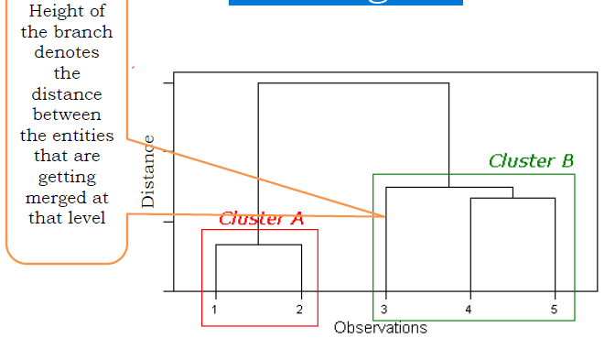

**SLIDE-28**

**Why cluster universities?**

• How can clustering help a prospective applicant?

• How can clustering help a business school dean?

**SLIDE-29**

**Evaluating usefulness of clustering**

• What characterizes each cluster?

• Can you give a “name” to each cluster?

• Does this give us any insight?

Insights? Anything Interesting?

**SLIDE-30**

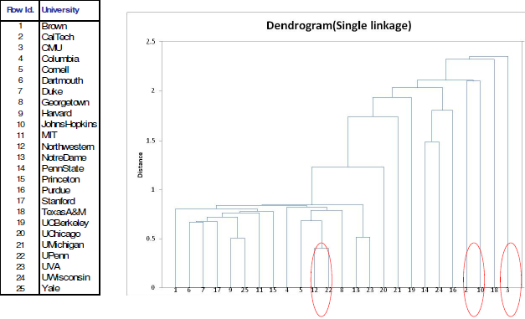

**SLIDE-31**

Dendrogram for Business School Example with Complete Linkage

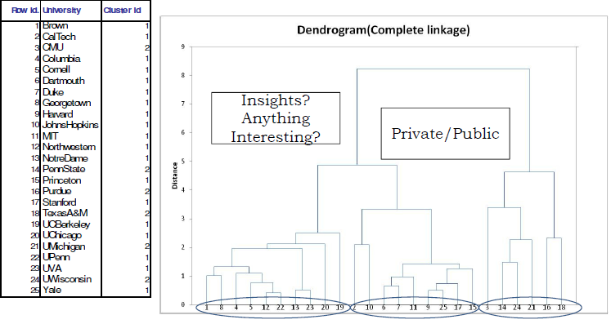

SLIDE-32

From Dendrograms to Clusters

• After dendrogram is obtained, cut it to create clusters. How?

• Examine distance levels

• Cut point determines # clusters

• Obtain statistics on resulting clusters

SLIDE-33

**Non-Hierarchical Clustering:**

**SLIDE-34**

**K-means clustering**

• Predetermined number (K) of non-overlapping clusters

• Clusters are homogeneous yet dissimilar to other clusters

• Need measures of within-cluster similarity (homogeneity) and between-cluster similarity

• No hierarchy (no dendrogram)! End Product is final cluster memberships.

**.** Useful for large data sets.

**SLIDE-35**

**K-means clustering**

Algorithm minimizes within-cluster variance (heterogeneity)

1. For a user-specified value of K, partition dataset into K initial clusters (next slide).

2. For each record, assign it to cluster with closest centroid

3. Re-calculate centroids for the “losing” and “receiving” clusters. can be done

• After reassignment of each record, or

• After one complete pass through all records (cheaper)

4. Repeat Steps 2-3 until no more reassignment is necessary

**SLIDE-36**

**Initial partition into K clusters**

Initial partitions can be obtained by either

1. user-specified initial partitions, or

2. user-specified initial centroids, or

3. Random partitions

**Stability**: Run algorithm with different initial partitions

**SLIDE-37**

**Selecting K**

• Re-run algorithm for different values of K

• Tradeoff: simplicity (interpretation) vs. adequacy (within-cluster homogeneity)

• Plot within-cluster variability as a function of K

Choice is subjective!

**SLIDE-38**

Why multiple start points (initial partitions) may be necessary?

• K-means clustering is a minimization problem

• Existence of multiple local minima

**SLIDE-39**

**Convergence/robustness of K-means**

• Procedure might oscillate indefinitely

• Convergence criterion:

– Stop when a cluster centroid moves less than a % of smallest distance between any of the centroids

– Specify the maximum number of iterations

**SLIDE-40**

**Final checks**

• Cluster stability: do cluster assignments change dramatically if some inputs are slightly altered?

• Cluster separation: compare between-cluster variation to within cluster variation.

**SLIDE-41**

**K-Means vs. Hierarchical**

**K-Means**

**The Good**

• Computationally fast for large datasets

• Useful when certain K needed

**The Bad**

• Can take long to terminate

• Final solution not guaranteed to be “globally optimal”

• Different initial partitions can lead to different solutions

• Must re-run the algorithm for different values of K

• No dendrogram

**Hierarchical**

**The Good**

• Finds “natural” grouping – no need to specify number of clusters

• Dendrogram: transparency of process, good for presentation

**The Bad**

• Require computation & storage of n x n distance matrix

• Algorithm makes only one pass through the data. Records that are incorrectly allocated early on cannot be reallocated subsequently

• Low stability: Reordering data or dropping a few records can lead to

different solution

• Single complete linkage robust to distance metric as long as the relative ordering is kept. Average linkage is

NOT.

• Most distances sensitive to outliers.

**SLIDE-42**

**Clustering Applications**

* American Girl
* Blockbuster vs Netflix
* Nike & Adidas hire Ethnographers
* Spotify